**Introduction to Kubernetes**

**Definition and Purpose of Kubernetes**

Kubernetes is an open-source container orchestration platform that automates the deployment, scaling, and management of containerized applications. It helps organizations efficiently manage their applications in a cloud-native environment.

**History and Evolution of Kubernetes**

* Originally developed by Google and released as an open-source project in 2014.
* Inspired by Google’s internal Borg system for managing containerized workloads.
* Now maintained by the Cloud Native Computing Foundation (CNCF).

**Key Benefits and Use Cases**

* **Scalability**: Automatically scales applications based on demand.
* **High Availability**: Ensures applications remain available through self-healing mechanisms.
* **Efficient Resource Utilization**: Distributes workloads efficiently across a cluster.
* **Portability**: Works across on-premises, hybrid, and multi-cloud environments.
* **Automated Deployments**: Supports CI/CD pipelines for faster application delivery.

**Challenges in Application Deployment**

**Issues with Traditional Deployment Methods**

* Manual deployment processes leading to errors and inefficiencies.
* Lack of consistency across different environments.

**Scalability and Availability Concerns**

* Difficulty in handling high traffic loads.
* Single points of failure in traditional deployment models.

**Dependency Management Challenges**

* Conflicts between software dependencies.
* Environment inconsistencies across development, testing, and production.

**Docker and Its Limitations**

**Basics of Docker Containers**

* Docker enables applications to run in isolated environments using containers.
* Containers package application code, dependencies, and runtime in a single unit.

**Drawbacks of Docker in Large-Scale Environments**

* Lack of built-in orchestration and automated scaling.
* Complexity in managing multiple containers and networking.

**Why Kubernetes is Needed for Orchestration**

* Automates container deployment, scaling, and networking.
* Manages workloads across multiple hosts efficiently.

**Kubernetes Architecture & Components**

**Master Node and Worker Node Architecture**

* **Master Node**: Manages cluster operations and makes scheduling decisions.
* **Worker Nodes**: Run application workloads within containers.

**Key Components**

* **API Server**: Exposes Kubernetes API for communication.
* **etcd**: Stores cluster configuration and state.
* **Controller Manager**: Monitors and maintains desired cluster state.
* **Scheduler**: Assigns workloads to worker nodes.
* **Kubelet**: Ensures containerized applications are running correctly.
* **Kube-proxy**: Manages network communication between nodes and services.

**Kubernetes Architecture**

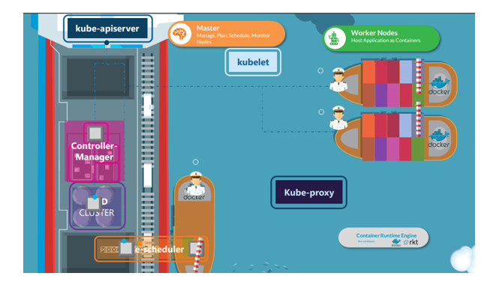

**Deep Dive into Control Plane and Node Components**

* The control plane manages cluster-wide operations.
* Worker nodes execute assigned workloads through pods.

**Interaction Flow Between Components**

* API Server acts as the communication hub.
* Scheduler assigns pods to worker nodes.
* Kubelet ensures pods are running as expected.

**Nodes, Pods, and Containers**

**Understanding Kubernetes Nodes**

* Nodes are individual machines that run containerized workloads.
* Each node contains a Kubelet, container runtime, and networking components.

**Pods as the Smallest Deployable Units**

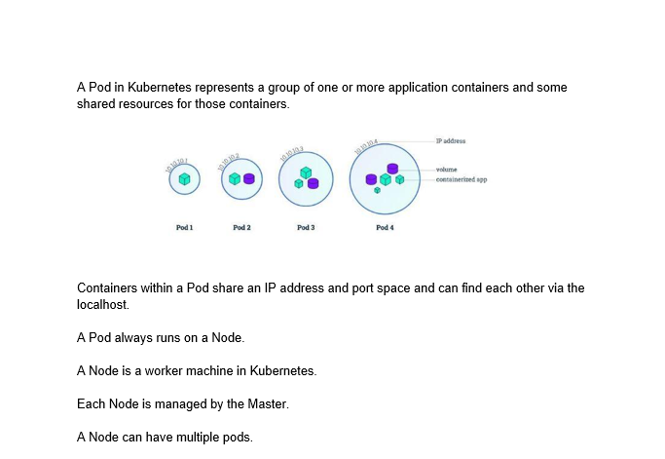**Container Runtime Overview**

* Kubernetes supports various container runtimes like Docker, containerd, and CRI-O.

**Cluster Management & Scaling**

**Horizontal and Vertical Scaling**

* **Horizontal Scaling**: Adding or removing nodes to adjust capacity.
* **Vertical Scaling**: Adjusting resource allocation for existing pods.

**Managing Cluster Resources Efficiently**

* Resource requests and limits ensure optimal resource distribution.
* Autoscalers dynamically adjust resources based on workload demand.

**1. Deploying an Nginx Pod**

**Question:**

You need to deploy a **simple Nginx application** on a Kubernetes cluster. How would you create a pod using **kubectl** and verify if it is running?

**Solution:**

* Create a pod with Nginx:

kubectl run nginx-pod --image=nginx --restart=Never

* Verify the pod status:

kubectl get pods

* Check pod logs:

kubectl logs nginx-pod

* Describe the pod to check for any issues:

kubectl describe pod nginx-pod

**2. Creating and Scaling a Deployment**

**Question:**

You need to create a **Kubernetes Deployment** that runs **3 replicas of an Nginx container** and then scale it up to 5 replicas. How would you achieve this?

**Solution:**

* Create the deployment:

kubectl create deployment nginx-deploy --image=nginx --replicas=3

* Verify the deployment:

kubectl get deployments

* Scale the deployment to 5 replicas:

kubectl scale deployment nginx-deploy --replicas=5

* Confirm the scaling:

• **Question:** What are the key differences between traditional deployment methods and Kubernetes-based deployments in terms of scalability and availability?  
**Answer:**

* Traditional deployments often rely on manual scaling and are prone to single points of failure.
* Kubernetes provides **automatic scaling** (Horizontal Pod Autoscaler) and **self-healing** (rescheduling failed pods).
* Kubernetes ensures **high availability** through **load balancing** and **replication controllers**, making applications more resilient.

• **Question:** Explain the role of the **Kubelet** and **Kube-proxy** in a Kubernetes worker node.  
**Answer:**

* **Kubelet**: Ensures that the containers in a pod are running and communicates with the control plane. It continuously monitors the pod's health and restarts containers if they fail.
* **Kube-proxy**: Manages network communication between pods and services. It maintains network rules and enables external access to Kubernetes services.